What is Accessibility?
Broadly speaking, accessibility is the measures an organization takes to accommodate the needs of all stakeholders, but especially those who have some form of impairment, to reasonably make use of its products or services, or to be employed by the organization. Accessibility is often simply about purposeful design.
We’ve been addressing how you can be purposeful in your design to remove barriers for those with vision impairments. From font choices to link structure, you can start to approach your digital media development with an awareness of how your choices affect those who need to use it.
Within accessibility standards is a lot of room to make your documents both accessible and creative. For instance, in discussing contrast, we suggested making sure the foreground and background colors of the content of your documents have sufficient contrast to be readable. That doesn’t mean you have to use dark text on a light back; you can invert the color scheme and still meet the standard:
This meets the standard and so does this.
Conversely, sometimes your choices will work for those with impairments but hinder those without:
Human readers may not be able to easily read this sentence, but a screen reader will do just fine. (Human readers may not be able to easily read this sentence, but a screen reader will do just fine.) - This is Kunstler Script in font size 16. It meets other accessibility requirements, but I really wouldn’t want to read a document that uses this font!
Accessibility is not about sameness, which means that you are not trying to provide the same experience for every user. The goal isn’t to make one bland website, email, Word document, Power Point presentation, etc. that everyone sees and interacts with exactly the same. You can’t hope to do that even without taking accessibility into account. Accessibility is about making the most enriching experience for all members of your audience.

Microsoft Word Accessibility Checker
One tool that you can use to find any glaring accessibility errors in your Word documents is Microsoft Word’s built-in accessibility checker.
- Open the Word document.
- Go to File > Info > Check for Issues > Check Accessibility. 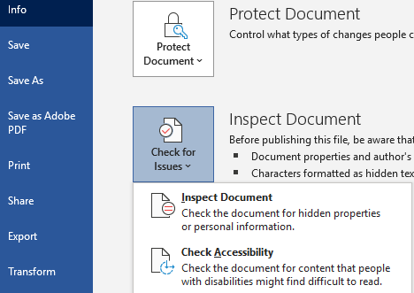
Finding the Accessibility Checker

Consider the examples I used above in describing how you can follow standards and be creative. When I examine them in Word’s accessibility checker, they pass:
Example of a successful Word accessibility check

Here’s what happens when your document has an issue:
Example of a failed Word accessibility check

